Daniel Goldstein

2425 E Northern Pkwy Fl 1

Baltimore, MD 21214-1140

(410) 491-3662 [dmgoldstein1@gmail.com](mailto:dmgoldstein1@gmail.com)

**Invoice #0023 for Services Rendered**

Friday, August 16, 2024

Dr. Carla Sandy

Sandy Audio Visual LLC

14625 Baltimore Ave #901

Laurel, MD 20707

(202) 494-4777

invoice@savweb.com

cc:

Colin Sandy

csandy@savweb.com

Andrea Jefferson

[andrea@savweb.com](mailto:andrea@savweb.com)

Hello Dr. Sandy,

Attached you will find an invoice for my consulting work at Carlisle Construction Company through Future Media Concepts Tuesday, August 6 through Thursday, August 8. The invoice enclosed reflects the rate of $625 per day of training, plus the cost of transportation to and from the area of work, and per diem expenses of $70 a day.

As I was ill Tuesday afternoon and unable to complete the rest of the training that day (five hours) and per emails with Colin and Tom Willson at FMC, I will only bill SAV for two days training. I will bill for the final full day if and when the end client uses the remaining five hours.

Please let me know if there is anything else I can do. I can be paid via ACH as you have done in the past.

Thank you very much. It was a pleasure to work for your client and I look forward to the next opportunity to do so. Also, please feel free to share any constructive criticism you received regarding my performance.

Sincerely,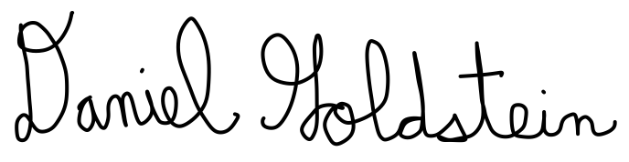

Daniel Goldstein

Audiovisual Professional

Attached:

Invoice #0023

Daniel Goldstein

2425 E Northern Pkwy Fl 1

|  |  |  |
| --- | --- | --- |
| **Date** | **Job Description** | **Day Rate/Expense** |
| Wednesday, August 7, 2024 | TriCaster Systems Consulting  for Carlisle Construction | $625.00 |
| Thursday, August 8, 2024 | TriCaster Systems Consulting  for Carlisle Construction | $625.00 |
| Tuesday, August 6, 2024 | 95 miles to client site @ 67¢/mile | $63.65 |
| Tuesday, August 6, 2024 - Thursday, August 8, 2024 | Receipt 1: Per Diem Expenses | $5.60 |
| Receipt 2: Per Diem Expenses | $8.35 |
| Receipt 3: Per Diem Expenses | $3.00 |
| Receipt 4: Per Diem Expenses | $22.17 |
| Receipt 5: Per Diem Expenses | $17.81 |
| Receipt 6: Per Diem Expenses | $23.88 |
| Receipt 7: Per Diem Expenses | $5.13 |
| Receipt 8: Per Diem Expenses | $19.93 |
| Receipt 9: Per Diem Expenses | $7.60 |
| Thursday, August 8, 2024 | 95 miles from client site @ 67¢/mile | $63.65 |
| **Total:** | | $1490.77 |

Baltimore, MD 21214-1140

(410) 491-3662 [dmgoldstein1@gmail.com](mailto:dmgoldstein1@gmail.com)